

School of Engineering and Information Technology
ASSIGNMENT COVER SHEET

- Please complete and insert this form as the first page of EACH electronic assignment.
- Submit the assignment with attached coversheet electronically as per the instructions in the Assignment Question sheet.
- Please make sure you keep a copy of the assignment.

Student Details
Surname | Kumaar | Given name | Kahmesh
Student Number | 34559625 | Email | Kahmesh@gmail.com

Assignment details
Unit name | Principles of Computer Science | Unit Code | ICT 167
Unit Coordinator | Mr.  Siew Cheong Chong | Tutor/Tutorial time | 6:30 pm to 8:30pm
Due date/time | 25 June 2022  11:59pm | Submission date | 25 June 2022
Assignment title | Coin denomination
Other information

All forms of plagiarism, cheating and unauthorized collusion are regarded seriously by the University and could result in penalties including failure in the unit and possible exclusion from the University. If in doubt, please contact the Unit Coordinator.

Student’s Declaration
Please double click on all the check boxes.

Except where I have indicated, the work I am submitting in this assignment is my own work and has not been submitted for assessment in another unit.

This submission complies with Murdoch University policies regarding plagiarism, cheating and collusion.

I have retained a copy of this assignment for my own records.

External Documentation

- Monetary change denomination program, Kahmesh Kumaar, 24/06/2022, ICT167assignment1.doc, Change. Java, Client. Java. This is a monetary change program that allows the client to store a name and coin that they have and retrieve their respective denomination.

- The program is supposed to record peoples name and the number of coins that they have. This is than to be stored in an array. It should also check that no same names are entered. During the process of inputting the name and coins for each person if after an input the user and go out of loop by pressing the program is than to sort the coins into denominations giving priority to a higher coin value in this case $1. It is than supposed to display a menu to the user. For option one to three it should give the name that is input and the appropriate denomination whether it is the biggest or smallest. Option 4 is to calculate the total number of coins for each denomination and option 5 to display total and sum of all denominations. Option 6 is to exit the program.

- Open java file in eclipse or any IDE that you used. Eclipse version 2022-03 (4.23.0). Java version javaSE-17 was used. Run client program. A terminal or console should appear. Key in name in console/terminal. Key in number of coins. If you want to continue to the next person, click Y. If not click N. A menu will appear displaying six options. Choose the appropriate option and the program will give you the results. To exit click option 6
- Pseudo code

Change Class

- Make a package
- Declare private variable for name and amount
- Make variable as current object within constructor
- Call another constructor
- Supply methods for setting and getting name
- Supply methods for setting and getting amount
- Set method for instance variable name to ensure input is not empty or contain whitespace
- Set method for amount
- Apply parameterized constructor to take name in string and amount in int
- Make calculation class array for coin
- Declare amounts
- Apply calculations for denominations respectively for $1,50 cents,25cents, 10 cents and 5 cents.
$1= amount/100
50cents=(amount%100)/50
- Create array for denomination and return denomination count back

Client Class
- Make package
- Import scanner to ask for user input
- Client class
- Create method to display change for name entered
- Create array list for denomination
- Get input from string
- For loop
- Calculate change of each denomination
- Display count of each denomination
- End for loop
- Create method for smallest denomination
- Create and set variable for finding minimum amount
- Set index to zero for record
- For loop to sort
- Display smallest denomination
- Create method for largest denomination
- Create variable for largest amount
- Set index to zero for record
- Create method for total denom and total sum
- Create array to store denominations
- Variable to store sum of all coins
- Display total denomination coins
- Create total amount and sum for all denomination
- Create array list
- Create student info method
- Main method
- Call student info method to display
- Create scanner
- Declare variables for menu,name,char and amount
- Declare iterator
- Variable to store person name
- Hardcoded values
- Display enter name
- Boolean true ask user enter name and amount
- Check amount multiple of 5 if not round off
- Check if user is new if true add
- Ask user if more people is needed to be added ‘Y’,’N’
- Change input to uppercase
- If ‘N’
- Do-while loop
- Display menu
- Use switch case check and compare user input
- Check if invalid input is added
- Call case for each option
- Option 6
- Loop end

4.

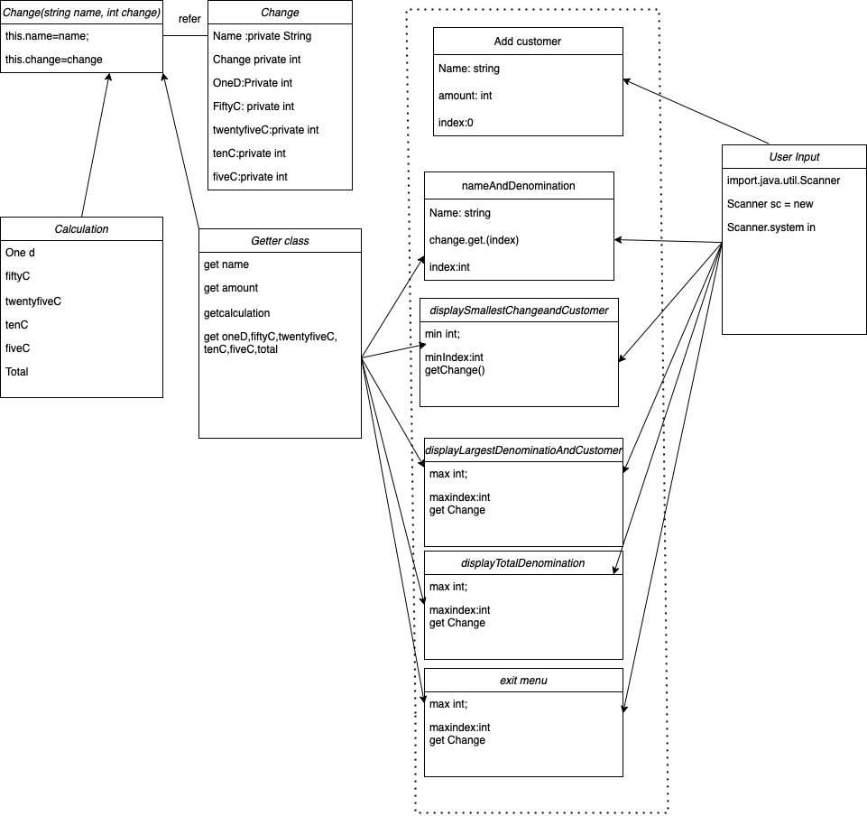
5.

O-O design concept

Information hiding:

Using private classes such as,private String name;,private int amount;

Getter and setter methods for the name and change:
public String getName()
getting the amount.

{
return name;
}

public int getAmount()
{
return amount;
}

Encapsulation:

int denom[] = new int[5];

public Change()// default constructor for Change.class
{
name = "someone";
amount = 0;
}

Pre-conditions :

2 instance variable (name,amount):
private String name;
private int amount;

instance variable (5 denomination of coins):

int oneD, fiftyC, twentyFiveC, tenC, fiveC;

Instance variable should be declared as private

Default constructor (name):
Public Change()
{name =””
Amount=0;
}

1 construtor with two parameter:
public Change( String name, int amount)
{
this.name=name;
this.amount=amount;
}

Public Change(String name, int amount)

Get and set method :
public void setName(String name)
{
this.name = name;
}
public void setAmount(int amount)
{
this.amount = amount;
}

Post condition:

Calculations
public int[]calculate()

Menu option:
switch(change_menu)

Invalid menu option:
System.out.println("Invalid option.Please try again");

}

}while (change_menu !=6);

Constructor:

public Change()// default constructor for Change.class
{
name = "someone";
amount = 0;
}
Student info()

6.Limitations
The programs limitations are that it cannot get average amount if needed. It is also limited

7.
Test Table
Test  Id | Test description/Justification-what is the test for and why this particular test. | Actual data for this test | Expected output | Actual desk check result when desk desk is carried out | Desk check outcome-Pass/Fail
1 | Typing the name and amount of 1 person see if it continues and message is displayed that asks user if they want to continue | Mesh ,45, Y | Program prompt user to enter another person name | Program prompt user to enter another person name | Pass
2 | Checking if after pressing ‘Y’ does it prompt me to enter another user | Mesh,45,Y, | Program prompts user to enter another name | Program prompts user to enter another name | Pass
3 | Checking if after adding 10 people and amount and press n does menu appear | Mesh,45, Y,Aby,135,Rinku,15,Y  ,Steve,60,Y,Yash,65,Y,  Niresh,20,Y,Trevor,168,Y,rong,45,Y,Ching,22,  Y,Tinesh,150,Y,Hasith,80,N | Exits loop and menu is displayed | Exits loop and menu is displayed | Pass
4 | When menu is displayed, click option 1 to check if the correct denomination will be prompted | Mesh,45, Y,Aby,135,Rinku,15,Y  ,Steve,60,Y,Yash,65,Y,  Niresh,20,Y,Trevor,168,Y  ,rong,45,Y,Ching,22,  Y,Tinesh,150,Y,Hasith,80,  N,1,Aby | Displays  Customer:Aby  Change:  $1:1  25cents:1  10cents:1 | Displays  Customer:Aby  Change:  $1:1  25cents:1  10cents:1 | Pass
5 | Upon clicking option 1 entering a new name that was not in the system to see if not found message will diaply and menu will be re-displayed | Mesh,45, Y,Aby,135,Rinku,15,Y  ,Steve,60,Y,Yash,65,Y,  Niresh,20,Y,Trevor,168,Y  ,rong,45,Y,Ching,22,  Y,Tinesh,150,Y,Hasith,80,  N,1,Ritz | Display  Name: Ritz  Not found  Re-display menu | Display  Name: Ritz  Not found  Re-display menu | Pass
6 | Click option 2 to see if largest customer and change breakdown is given and rounded off to nearest 5 | Mesh,45, Y,Aby,135,Rinku,15,Y  ,Steve,60,Y,Yash,65,Y,  Niresh,20,Y,Trevor,168,Y  ,rong,45,Y,Ching,22,  Y,Tinesh,150,Y,Hasith,80,  N,2 | Display  Name:  Trevor  Change:  $1: 1  50cents:  1  10 cents: 2 | Display  Name:  Trevor  Change:  $1: 1  50cents:  1  10 cents: 2 | Pass
7 | Click option 3 to see if smallest customer and change breakdown is given and rounded off successfully | Mesh,45, Y,Aby,135,Rinku,15,Y  ,Steve,60,Y,Yash,65,Y,  Niresh,20,Y,Trevor,168,Y  ,rong,45,Y,Ching,22,  Y,Tinesh,150,Y,Hasith,80,  N,3 | Displays  Customer:  Ching  Change:  10 cents: 2 | Displays  Customer:  Ching  Change:  10 cents: 2 | Pass
8 | Click option 4 to see if total change breakdown is given | Mesh,45, Y,Aby,135,Rinku,15,Y  ,Steve,60,Y,Yash,65,Y,  Niresh,20,Y,Trevor,168,Y  ,rong,45,Y,Ching,22,  Y,Tinesh,150,Y,Hasith,80,  N,4 | Change:  $1:3  50 cents  :5  25 cents  :4  10 cents  :14  5 cents  :3 | Change:  $1:3  50 cents  :5  25 cents  :4  10 cents  :14  5 cents  :3 | Pass
9 | Click option 5 to see if total sum of change breakdown is given | Mesh,45, Y,Aby,135,Rinku,15,Y  ,Steve,60,Y,Yash,65,Y,  Niresh,20,Y,Trevor,168,Y  ,rong,45,Y,Ching,22,  Y,Tinesh,150,Y,Hasith,80,  N,5 | Total amount:  7 dollars  And 55 cents | Total amount:  7 dollars  And 55 cents | Pass
10 | Click option 6 to check if program can end | Mesh,45, Y,Aby,135,Rinku,15,Y  ,Steve,60,Y,Yash,65,Y,  Niresh,20,Y,Trevor,168,Y  ,rong,45,Y,Ching,22,  Y,Tinesh,150,Y,Hasith,80,  N,6 | Prompt thank you for using this program goodbye | Prompt thank you for using this program goodbye | pass
11 | Check if student info  Is displayed | Running the program | Student name: Kahmesh  Student number: 34559625  Mode of enrolment:Online  Teacher name:Mr.Siew Cheong Chong  Day :Saturday Time:12pm | Student name: Kahmesh  Student number: 34559625  Mode of enrolment:Online  Teacher name:Mr.Siew Cheong Chong  Day :Saturday Time:12pm | pass

Result of program testing

Test id | Test description/ justification | Actual data for this test | Expected output | Actual  Program output | Test run outcome  Pass/fail
1 | Checking if after adding 10 people and amount and press n does menu appear | Mesh,45, Y,Aby,135,Rinku,15,Y  ,Steve,60,Y,Yash,65,Y,  Niresh,20,Y,Trevor,168,  Y,rong,45,  Y,Ching,22,  Y,Tinesh,150,Y,Hasith,80,N | Exits loop and menu is displayed | Error message | Fail
2 | When menu is displayed, click option 1 to check if the correct denomination will be prompted | Mesh,45, Y,Aby,135,Rinku,15,Y  ,Steve,60,Y,Yash,65,Y,  Niresh,20,Y,Trevor,168,Y  ,rong,45,Y,Ching,22,  Y,Tinesh,150,Y,Hasith,80,  N,1,Aby | Displays  Customer:Aby  Change:  $1:1  25cents:1  10cents:1 | Error message | Fail
3 | Upon clicking option 1 entering a new name that was not in the system to see if not found message will diaply and menu will be re-displayed | Mesh,45, Y,Aby,135,Rinku,15,Y  ,Steve,60,Y,Yash,65,Y,  Niresh,20,Y,Trevor,168,Y  ,rong,45,Y,Ching,22,  Y,Tinesh,150,Y,Hasith,80,  N,1,Ritz | Display  Name: Ritz  Not found  Re-display menu | Error message | Fail
4 | Click option 2 to see if largest customer and change breakdown is given and rounded off to nearest 5 | Mesh,45, Y,Aby,135,Rinku,15,Y  ,Steve,60,Y,Yash,65,Y,  Niresh,20,Y,Trevor,168,Y  ,rong,45,Y,Ching,22,  Y,Tinesh,150,Y,Hasith,80,  N,2 | Display  Name:  Trevor  Change:  $1: 1  50cents:  1  10 cents: 2 | Error message | Fail
5 | Click option 3 to see if smallest customer and change breakdown is given and rounded off successfully | Mesh,45, Y,Aby,135,Rinku,15,Y  ,Steve,60,Y,Yash,65,Y,  Niresh,20,Y,Trevor,168,Y  ,rong,45,Y,Ching,22,  Y,Tinesh,150,Y,Hasith,80,  N,3 | Displays  Customer:  Ching  Change:  10 cents: 2 | Error message | Fail
6 | Click option 4 to see if total change breakdown is given | Mesh,45, Y,Aby,135,Rinku,15,Y  ,Steve,60,Y,Yash,65,Y,  Niresh,20,Y,Trevor,168,Y  ,rong,45,Y,Ching,22,  Y,Tinesh,150,Y,Hasith,80,  N,4 | Change:  $1:3  50 cents  :5  25 cents  :4  10 cents  :14  5 cents  :3 | Error message | Fail
7 | Click option 5 to see if total sum of change breakdown is given | Mesh,45, Y,Aby,135,Rinku,15,Y  ,Steve,60,Y,Yash,65,Y,  Niresh,20,Y,Trevor,168,Y  ,rong,45,Y,Ching,22,  Y,Tinesh,150,Y,Hasith,80,  N,5 | Total amount:  7 dollars  And 55 cents | Error | fail
8 | Click option 6 to check if program can end | Mesh,45, Y,Aby,135,Rinku,15,Y  ,Steve,60,Y,Yash,65,Y,  Niresh,20,Y,Trevor,168,Y  ,rong,45,Y,Ching,22,  Y,Tinesh,150,Y,Hasith,80,  N,6 | Prompt thank you for using this program goodbye | Error | Fail

